Tox-Scraper MCP — Traceability Design
Regulator-grade audit trail · Independent of deliverable · Linked by workflow_id · April 2026

1. Intent
Traceability is a first-class requirement. Every run of the tox-scraper MCP must emit, alongside the deliverable Word report, a separate audit-trail package that captures how the deliverable was produced. The two artifacts are stored in independent volumes — the deliverable in /reports, the traceability bundle in /trace — and are linked only by a shared workflow_id. A reviewer with access to the bundle can reconstruct, verify, and if necessary disprove every sentence in the final report without re-running the pipeline.
2. The 10 Requirements → Concrete Artifacts
# | Requirement | Artifact | Emitted by
1 | Search criteria | search_log.jsonl | sources/*.search()
2 | Databases searched | search_log.jsonl + manifest | MultiDatabaseHarvester
3 | Date/time of searches | search_log.jsonl (ISO-8601 UTC) | TraceabilityRecorder
4 | API + agent versions | environment.json | bind_run()
5 | Paper inclusion/exclusion | inclusion_log.jsonl | sources/_base.harvest_one
6 | Reasons for exclusion | inclusion_log.reason_code | same
7 | Extraction + reconciliation | extraction_log.jsonl + evidence.jsonl | PDFExtractor / HTMLExtractor
8 | Evidence weighting logic | weighting_log.jsonl | pipeline/harvest._confidence
9 | Synthesis steps + transformations | transformations.jsonl | pipeline/review composers
10 | Manual interventions | interventions.jsonl | operator CLI / API endpoint

3. Separation & Linkage Model
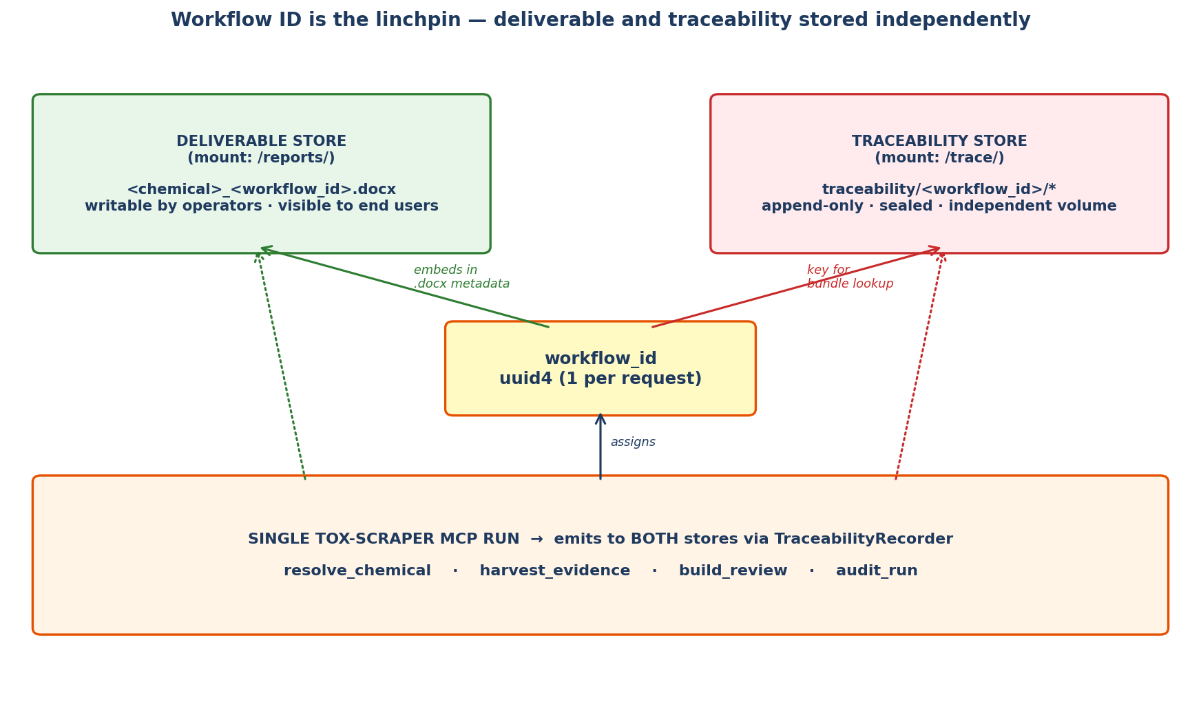
The workflow_id is a UUID4 generated at the first tool call of a session. It is carried through resolve_chemical → harvest_evidence → build_review → audit_run and embedded in three places: the .docx core properties, a visible footer on the report, and the filename suffix. The same workflow_id is the folder name inside the traceability store. There is no content-level cross-reference between the two stores — only the workflow_id. This means the deliverable can be forwarded, archived, or republished without exposing the audit trail, while a reviewer can always fetch the traceability package by id.
Why two stores
- Independence — a compromise of /reports does not compromise the audit trail
- Append-only — /trace is mounted with write-once semantics so records cannot be silently edited
- Different retention — /reports may be pruned; /trace is kept for the regulatory window
- Different ACLs — reviewers/auditors get read-only /trace; operators get /reports

4. Package Layout
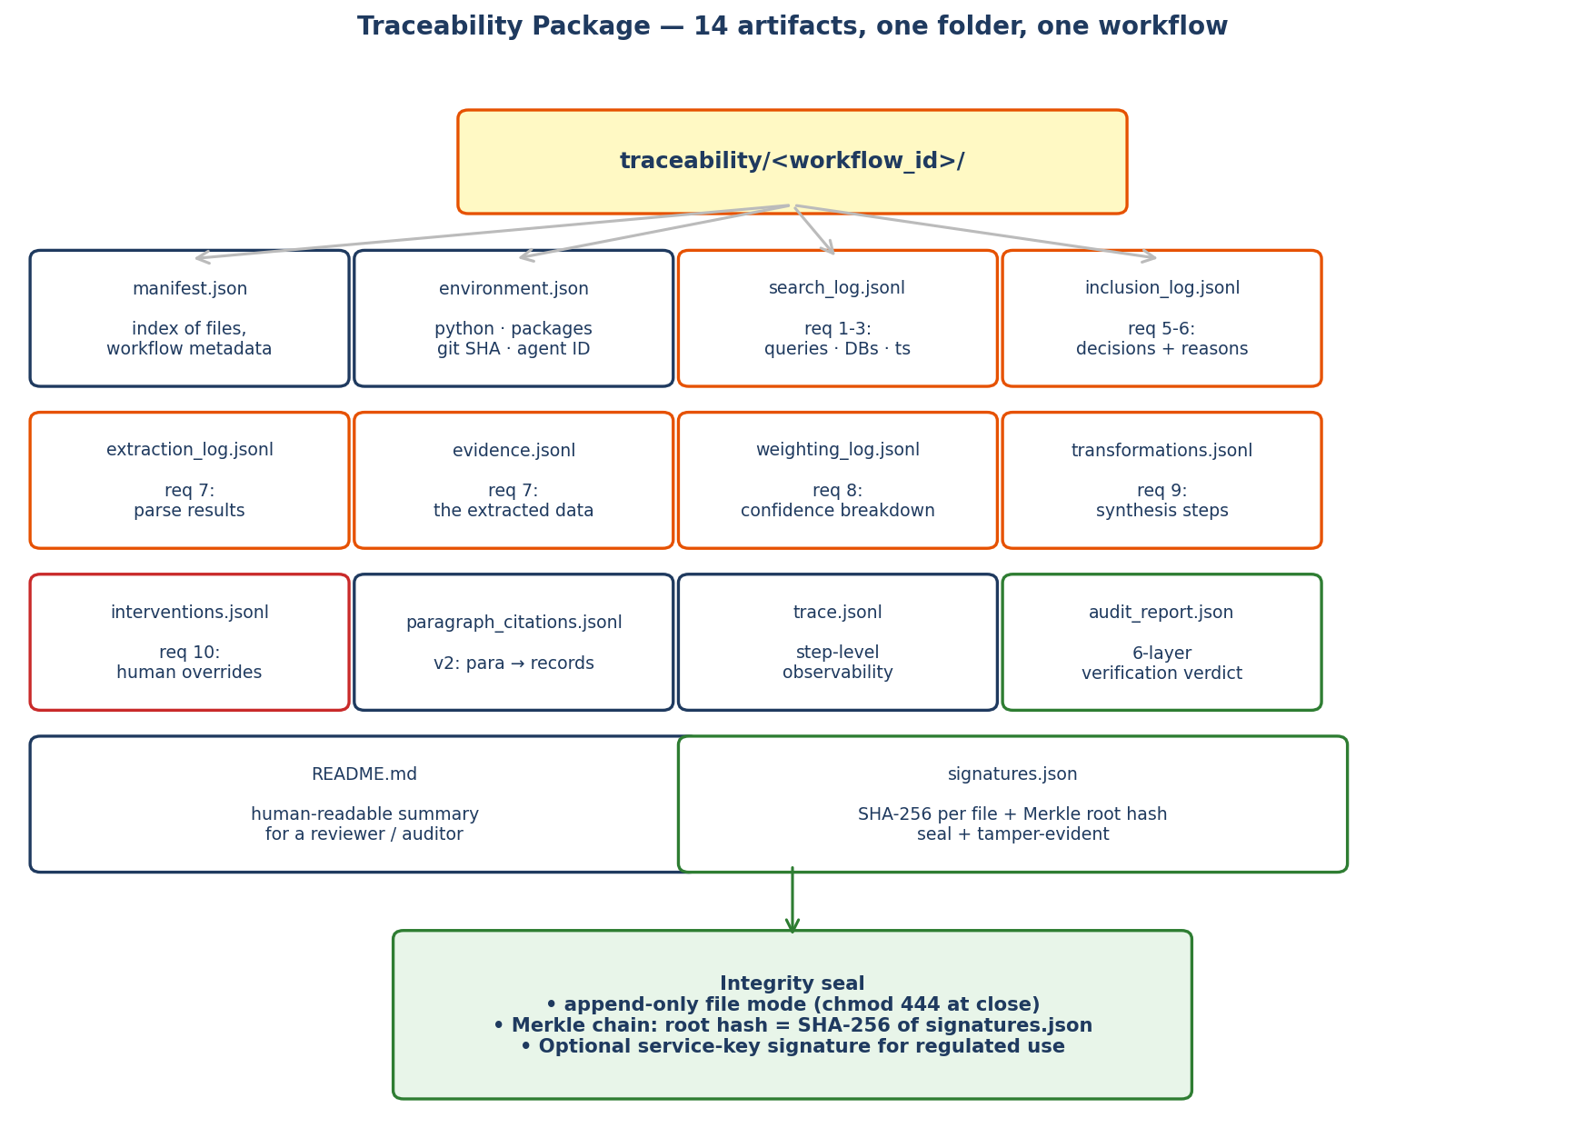
Per-file purpose (beyond the diagram)
manifest.json
Top-level index. Records workflow_id, chemical name, requester, pipeline version, start/end timestamps, list of every file in the bundle with its SHA-256, and the Merkle root hash of signatures.json. A reviewer opens this first.
{ "workflow_id": "f3c1a0e2-...",
"chemical": "formaldehyde",
"cas": "50-00-0",
"requester": "ABYadav@scitovation.com",
"pipeline_version": "tox_scraper@1.4.0",
"git_sha": "a91f4c2",
"started_utc": "2026-04-23T14:22:08Z",
"ended_utc": "2026-04-23T14:27:41Z",
"agent": { "host": "claude_desktop", "model": "claude-opus-4-7" },
"files": [ {"name": "search_log.jsonl", "sha256": "..."}, ... ],
"merkle_root": "sha256:71c4...e9" }
environment.json — requirement 4
Fully specifies the software state at run time. Snapshotted by bind_run() before any external call is made. Makes builds reproducible at the versioned-dependency level.
{ "python": "3.11.8",
"os": "Ubuntu 22.04",
"packages": { "httpx":"0.27.0", "python-docx":"1.2.0", ... },
"tox_scraper": { "version":"1.4.0", "git_sha":"a91f4c2", "dirty":false },
"configs": { "sections.py_sha":"...", "databases.py_sha":"...",
"keyword_count":570, "section_count":29 },
"agent": { "host":"claude_desktop", "model":"claude-opus-4-7",
"client_version":"1.27.0" },
"api_endpoints": { "pubmed":"eutils.ncbi.nlm.nih.gov/e3.3.1",
"echa":"echa.europa.eu/information-on-chemicals v2", ... } }
search_log.jsonl — requirements 1, 2, 3
One line per executed query. Captures the raw query string, the resolved query (after chemical ID substitution), the database hit, the API endpoint and version, HTTP status, wall-clock duration, and the number of raw hits returned.
{ "ts":"2026-04-23T14:22:09.113Z", "workflow_id":"f3c1a0e2",
"step":"search", "database":"PubMed",
"query_template":"{chem} AND carcinogenicity",
"resolved_query":"formaldehyde[tiab] AND carcinogenicity",
"endpoint":"https://eutils.ncbi.nlm.nih.gov/entrez/eutils/esearch.fcgi",
"api_version":"e3.3.1", "http_status":200,
"duration_ms":412, "hit_count":187 }
inclusion_log.jsonl — requirements 5, 6
One line per PaperRef encountered. Records the include/exclude decision with a controlled-vocabulary reason code — e.g. PDF_UNAVAILABLE, TEXT_EXTRACTION_FAILED, NO_KEYWORD_MATCH, DUPLICATE_DOI, OUT_OF_SCOPE_YEAR, PAYWALL_NO_OA, HTTP_4XX. A human-readable reason_detail supplements the code for the audit trail.
{ "ts":"2026-04-23T14:22:34.811Z", "workflow_id":"f3c1a0e2",
"database":"PubMed", "paper_id":"pmid:37452119",
"doi":"10.1289/EHP10244", "decision":"excluded",
"reason_code":"NO_KEYWORD_MATCH",
"reason_detail":"no section keyword found in abstract or full text",
"evaluated_at_step":"harvest_one" }
extraction_log.jsonl — requirement 7
Per-document record of the extraction pipeline: which extractor ran (pdfminer, pypdf fallback, PMC JATS, HTML), pages parsed, tables extracted, figures captured, word count, and any reconciliation notes (e.g. pdfminer failed at page 14, pypdf succeeded — reconciled).
evidence.jsonl — requirement 7 (the extracted data itself)
Copy of the ledger produced by harvest_evidence. Inside the traceability bundle it is sealed and hashed alongside the other artifacts; the operational copy in /tmp/tox_runs is for the pipeline's own use.
weighting_log.jsonl — requirement 8
Opens the black box of the confidence formula. For every evidence record we write the components that went into the score so an auditor can reproduce the arithmetic by hand.
{ "record_id":"rec_0142", "workflow_id":"f3c1a0e2",
"formula":"0.30 + 0.15*n_cat + 0.05*min(5, n_hits)",
"base":0.30, "n_categories":2, "category_bonus":0.30,
"n_hits":4, "hit_bonus":0.20, "final":0.80,
"clipped_at_1":false }
transformations.jsonl — requirement 9
Records every synthesis step performed during build_review: excerpt deduplication, section routing, citation numbering, prelude assembly, section-specific formatting. Each entry names the operation, input record IDs, output paragraph IDs, and parameter values.
{ "ts":"2026-04-23T14:25:12.001Z", "workflow_id":"f3c1a0e2",
"step":"compose_section", "section":"carcinogenicity",
"operation":"select_top_excerpts",
"params":{ "max_per_section":14, "dedupe":"by_doi_then_title" },
"input_record_ids":["rec_0142","rec_0517","rec_0991","rec_1034"],
"output_paragraph_ids":["ch5.carcinogenicity.p1","...p2","...p3"],
"dropped_records":[{"id":"rec_2203","reason":"DUPLICATE_DOI"}] }
interventions.jsonl — requirement 10
Captures any manual override: a reviewer removing a paper, adjusting a confidence threshold, rerunning a single section, editing the docx. An intervention always includes actor identity, ISO-8601 timestamp, the before state, the after state, and a free-text reason. For fully automated runs the file is empty but present — an empty file is itself evidence of no intervention.
{ "ts":"2026-04-23T14:30:22.417Z", "workflow_id":"f3c1a0e2",
"actor":"ABYadav@scitovation.com",
"action":"exclude_record", "target":"rec_0991",
"before":{ "included":true }, "after":{ "included":false },
"reason":"retraction notice issued 2025-11; removed per SOP-17" }
paragraph_citations.jsonl — from blueprint v2
Links every paragraph in the .docx to the specific ledger records it cited, with span hashes. This closes the loop from the deliverable back to the raw extraction data. Already designed in the v2 blueprint.
trace.jsonl
The existing step-level observability log. Tells the reviewer what ran, when, in what order, and which steps errored. Complements but does not replace the specialised logs above.
audit_report.json
The verdict from the six-layer audit_run (structural / anchor / substring / citation integrity / URL liveness / corroboration). Makes the verification result a first-class artifact of the bundle.
README.md
Auto-generated human-readable summary for a reviewer who does not want to open JSONL files: chemical, workflow_id, counts (papers evaluated, included, excluded by reason), audit verdict, interventions summary, links to each file.
signatures.json
SHA-256 of every other file in the bundle plus a Merkle root that is the hash of the sorted list of file hashes. Tampering with any single file changes the root, which is mirrored in manifest.json. Optional: a service-key signature over the root hash for regulated deployments.

5. Implementation Footprint
New module
Add core/traceability.py with a single TraceabilityRecorder class. It owns handles to the 14 artifact files in the bundle, exposes typed methods such as record_search(), record_decision(), record_weighting(), record_transformation(), record_intervention(), and seals the bundle on close() (chmod 444, write signatures.json, write manifest.json).
Call sites (small diffs)
- sources/_base.BaseDatabaseSource.search() — one call to record_search()
- sources/_base.harvest_one() — one call to record_decision() per PaperRef (included or excluded)
- pipeline/harvest._confidence() — one call to record_weighting() per record
- pipeline/review composers — one call to record_transformation() per step
- tools/context.bind_run() — instantiate recorder, snapshot environment.json
- tools/context.close_run() — recorder.seal() (compute hashes + manifest)
Workflow ID propagation
Replace the current ad-hoc run_id with workflow_id everywhere (uuid4, not timestamp). Add workflow_id to the docx core properties via python-docx, to the page footer on every page, and as a suffix in the output filename. A small helper looks up the traceability bundle URL from workflow_id.
Operator interventions
Expose two small MCP tools for authenticated operators: record_intervention (append to interventions.jsonl on an already-sealed bundle via a supplementary file, preserving append-only semantics) and replay_run (load a workflow_id and rebuild the deliverable from its evidence.jsonl — useful after an intervention that merely excludes a retracted paper).
Storage & retention
- Deliverable store: /reports/, standard filesystem, pruneable
- Traceability store: /trace/, mounted append-only (e.g. S3 Object Lock / WORM)
- Retention: /trace default 7 years (configurable per regulatory regime)
- Backups: /trace rsynced to offline cold storage nightly
6. Integrity Controls
- Append-only JSONL — files opened in 'ab' mode, never rewritten in place
- chmod 444 at seal time — host OS enforces read-only after run ends
- SHA-256 per file + Merkle root in manifest.json — tamper-evident
- Optional service-key signature over Merkle root for regulated workflows
- ISO-8601 UTC timestamps everywhere, with clock source attribution
- WORM storage for /trace in production (S3 Object Lock or equivalent)
7. Reviewer / Auditor Flow
A regulator, internal reviewer, or client auditor receives just the .docx. From its footer or core-properties they read workflow_id. They request the traceability bundle from /trace/<workflow_id>/. They open README.md for orientation, manifest.json to verify the Merkle root, then drill into whichever specific log answers their question — which papers were searched, why a particular paper was excluded, how a specific confidence score was computed, or whether any manual intervention occurred. Every answer is one JSONL line away.
8. Open Questions Before Build
- Which WORM backend for /trace — S3 Object Lock, Azure Blob immutable, local ZFS?
- Retention window — 7 years default, or longer per FDA 21 CFR Part 11 / EU REACH?
- Who signs the Merkle root — HSM-backed service key, or operator key?
- Should signature covers LLM-judge and human-panel scores too? (Probably yes.)
- Do we need a second 'witness' process to co-sign for dual-control workflows?
9. Summary
All ten traceability requirements map cleanly onto existing scrapper-mcp machinery. Nothing about the pipeline architecture needs to change — we add one new core module (TraceabilityRecorder), attach it at six well-defined call sites, and emit a sealed bundle to an independent store linked by workflow_id. The deliverable remains a clean Word document a toxicologist can read on Monday morning; the traceability bundle remains a sealed, hash-chained audit trail an FDA or REACH reviewer can open five years later.

